Project Summary:
Predictive Modelling of Seasonal Soil Nutrient Balances (N, P, K, S)
Scope: Bogura, Cumilla, Muktagacha (Bangladesh) × 2 years × 4 seasons

Executive summary
- We built deployable ML models that predict seasonal nutrient balances (kg/ha) for N, P, K, S using your experimental data + public environmental data.
- Performance on test set (Figure 1):
  - N R² = 0.927, MAE ≈ 6.7 kg/ha
  - P R² = 0.984, MAE ≈ 1.5 kg/ha
  - K R² = 0.908, MAE ≈ 4.3 kg/ha
  - S R² = 0.887, MAE ≈ 1.0 kg/ha
- Best strategy per nutrient:
  - Difference approach (model inputs & outputs separately): N, P
  - Direct approach (predict net balance in one step): K, S
- Intended use: rapid, low-cost pre-season and in-season guidance on likely nutrient deficits or surpluses, to support fertiliser planning where lab testing is infeasible.

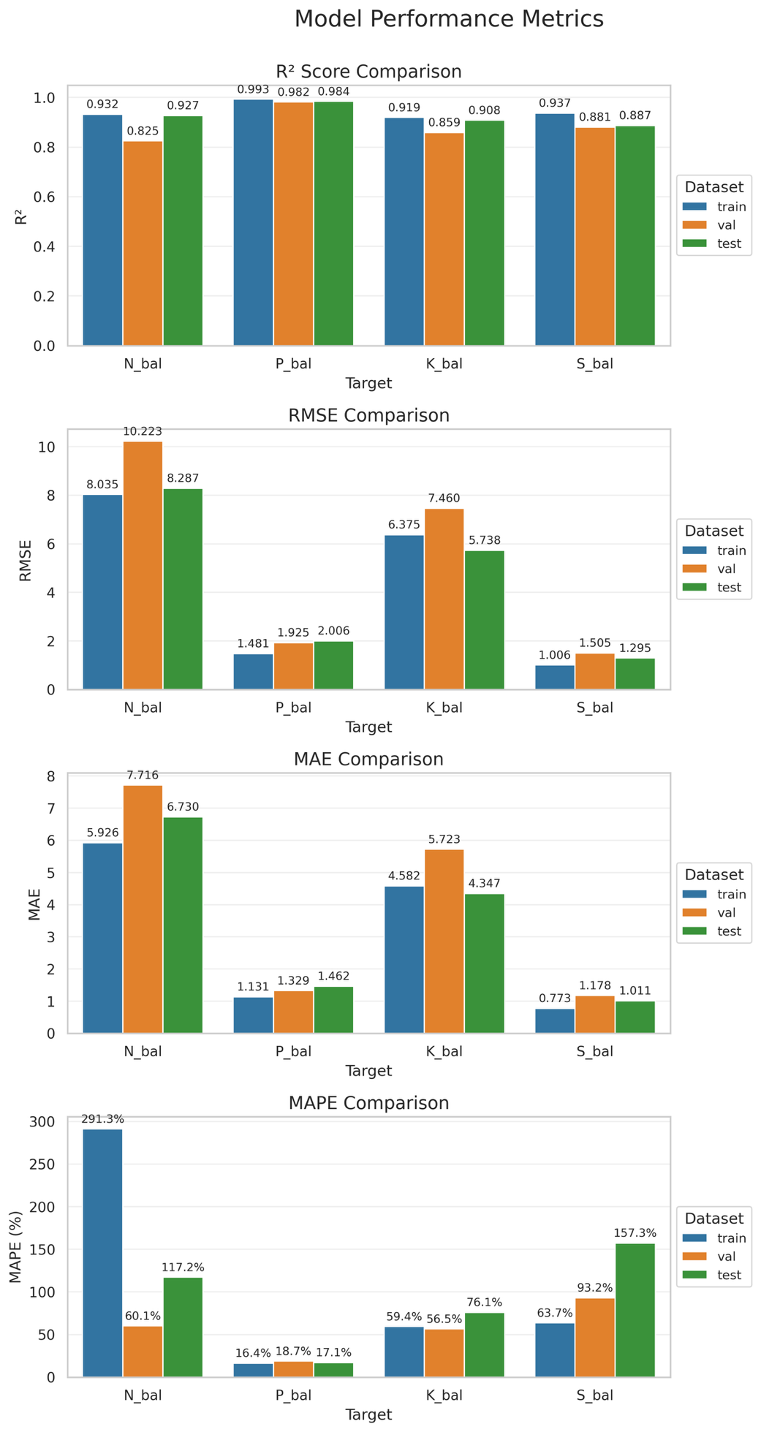

Figure 1: Model performance metrics

What was built
- Feature pipeline: 97 seasonal environmental features capturing radiation/energy, water status (rainfall, wetness, dry spells), atmospheric stress (temperature, humidity, VPD, THI), and wind; joined with control variables (location, crop, residue, fertiliser strategy).
- Model families: XGBoost, Random Forest, and MLP.
- Ensembles: nutrient-specific combinations to improve robustness (performance-weighted, equal-weighted, or reliability-weighted depending on nutrient).
- Saved models: four final ".pkl" artefacts ready to load and predict.

Practical value to GreenTecAI & customers
- Cost/time savings: estimates available without lab tests, enabling triage of where/when to test.
- Actionable planning: flag deficits (negative balances) or excess before next season to guide fertiliser adjustments.
- Scalable: uses public data (BMD + NASA) plus minimal field inputs (location, season, crop, residue, fertiliser strategy).
- Deployment-ready: reproducible scripts and serialised models; easy to wrap into a microservice or batch tool.

Inputs, outputs, and how to use

Inputs required at prediction time
- Location (district/site), crop, residue treatment (one of the two categories used in trials), fertiliser strategy (one of the four categories used in trials).
- Environmental features (pre-computed seasonal tables or computed from daily feeds).

Outputs
- Predicted seasonal nutrient balance (kg/ha) for N, P, K, S.
Interpretation
- Negative balance → expected deficit (consider supplementation or timing change).
- Positive balance → potential excess (risk of runoff/leaching, adjust down).
- Note: current fertiliser categories are coarse, so the tool indicates direction and magnitude rather than prescribing exact kg/ha fertiliser rates.

What drives predictions (high level)
- Strong signals from management (fertiliser strategy, residue), location, and season.
- Environmental drivers that frequently matter: thermal time/temperature structure, humidity/VPD stress, rainfall amount & dry-spell structure, radiation × moisture context.
- This aligns with agronomy: inputs reflect management + rainfall, outputs reflect crop uptake + losses (hence the advantage of the difference strategy for N and P).

Files you will receive (key items)
- Models: N_bal_diff_model.pkl, P_bal_diff_model.pkl, K_bal_direct_model.pkl, S_bal_direct_model.pkl
- Data: BAS_clean.xlsx, environmental_features.csv (+ dictionaries), df_full.csv, train_df.csv, val_df.csv, test_df.csv
- Feature engineering: BMD/NASA daily → seasonal notebooks; merged summaries (BMD_summary.csv, NASA_summary_all.csv)
- Modelling notebooks: Modelling_Direct_Approach.ipynb, Modelling_Difference_Approach.ipynb
- Deployment: Deployment and evaluation.ipynb (examples of loading models and predicting)
(See Appendix A for full inventory information in GitHub repository)

How to use for prediction
- Open Terminal on your laptop and switch to the directory where you save the model packages as well as the "app.py" file. For example:
  - On Windows: cd "C:\Users\Eurus\Documents\soil_models"
  - On MacOS: cd "/Users/eurus/Documents/soil_models"
(Please modify to your real, correct path)
- Input the following strings in terminal and press "Enter":
pip install streamlit scikit-learn pandas numpy joblib
streamlit run app.py
- The user interface will pop out.
- Follow the instructions on the UI and input predictor values to use.

Known limitations (and how to mitigate)
- Sample size & geography: models trained on three sites; start with these and expand cautiously.
- Fertiliser categories: four coarse strategies → good for directional planning, not exact kg/ha prescriptions. Collect continuous fertiliser rates to improve.
- MAPE caveat: balances near zero can inflate percentage errors; rely on MAE and sign for decision support.
- External data: NASA/BMD have resolution and imputation constraints; keep local agronomist in the loop.

Conclusions
We can now predict seasonal balances of N, P, K, and S using public weather data plus a few field inputs. The models are accurate, fast to run, and already packaged for deployment. They help us spot deficits or excess before the season, so we can adjust fertiliser plans where lab testing is not feasible. The workflow is reproducible, explainable, and designed to scale as we add more regions and more granular fertiliser data.

Appendix A: GitHub Repository

A.1 Repository link
GitHub repository: https://github.com/Eurus1089/MSIN0114_Dissertation_Soil_Project
The repository contains the processed datasets, modelling artefacts, and notebooks required to reproduce the analysis and deployment steps described in the dissertation. File names follow two conventions:
- _full = daily-level panels; _summary = seasonal aggregates.
- *.pkl = serialised final models or Python objects.

A.2 README of files (in alphabetical order)
BAS_clean.xlsx
Analytical version of the internal experimental dataset (plot–season level). Contains measured nutrient balances (N, P, K, S), experimental controls (location, crop, residue, fertiliser strategy), and identifiers used to join with environmental features.
BAS_data_full_dictionary.xlsx
Data dictionary for the BAS dataset (variable names, units, and descriptions).
BMD_data_full.xlsx
Cleaned daily Bangladesh Meteorological Department panel used to engineer seasonal features (temperature, humidity, rainfall, wind, etc.).
BMD_feature_engineer.ipynb
Notebook that imputes BMD gaps, encodes agronomic seasons, derives daily metrics, and aggregates to seasonal features. Outputs BMD_summary.csv.
BMD_summary.csv
Seasonal-level meteorological features by location and season derived from BMD_data_full.xlsx.
Combine_BMD_n_NASA_features.ipynb
Notebook that merges BMD_summary.csv and NASA_summary_all.csv, harmonises names, and produces the consolidated environmental feature table.
Combine_NASA_features.ipynb
Notebook that collates site-specific NASA seasonal summaries into NASA_summary_all.csv.
Deployment and evaluation.ipynb
End-to-end loading of final models (*.pkl), generation of predictions, and test-set evaluation/plots. Demonstrates deployment in a clean session.
df_full.csv
Final modelling table at plot–season level: BAS outcomes and controls joined to the consolidated environmental features. Used to create the train/validation/test splits.
environmental_features_data_dictionary_edited.xlsx
Data dictionary for the consolidated environmental feature set.
environmental_features.csv
Merged environmental feature matrix by location–season (BMD + NASA), used as the join key for BAS.
feature_groups.pkl
Python object mapping feature names to the ten thematic groups used in Stage-1 selection.
K_bal_direct_model.pkl
Serialised final model for K balance (direct approach).
Modelling_Difference_Approach.ipynb
Training pipeline for the difference strategy (separate input and output models; subtraction to obtain balance). Includes cross-validation, tuning, and model selection.
Modelling_Direct_Approach.ipynb
Training pipeline for the direct strategy (net balance as target). Includes cross-validation, tuning, and ensemble construction.
N_bal_diff_model.pkl
Serialised final model for N balance (difference approach).
NASA_data_bogura.csv
NASA POWER daily variables for Bogura (raw/cleaned daily panel used for feature engineering).
NASA_data_cumilla.csv
NASA POWER daily variables for Cumilla.
NASA_data_muktagacha.csv
NASA POWER daily variables for Muktagacha.
NASA_data_dictionary.xlsx
Dictionary for NASA variables (definitions, units, source notes).
NASA_feature_engineer_bogura.ipynb
Site-specific NASA feature engineering for Bogura (daily → seasonal).
NASA_feature_engineer_cumilla.ipynb
Site-specific NASA feature engineering for Cumilla.
NASA_feature_engineer_muktagacha.ipynb
Site-specific NASA feature engineering for Muktagacha.
NASA_summary_all.csv
Concatenated seasonal NASA features across all three sites.
NASA_summary_bogura.csv
Seasonal NASA features for Bogura.
NASA_summary_cumilla.csv
Seasonal NASA features for Cumilla.
NASA_summary_muktagacha.csv
Seasonal NASA features for Muktagacha.
P_bal_diff_model.pkl
Serialised final model for P balance (difference approach).
S_bal_direct_model.pkl
Serialised final model for S balance (direct approach).
test_df.csv
Held-out test split at plot–season level used only for final evaluation.
train_df.csv
Training split used for model fitting and hyper-parameter tuning.
val_df.csv
Validation split used for model selection and early stopping.

A.3 How to reproduce (summary)
- Clone the repository and open the notebooks in a clean Python environment.
- Run the NASA and BMD feature-engineering notebooks to regenerate NASA_summary_*.csv and BMD_summary.csv.
- Run Combine_NASA_features.ipynb and Combine_BMD_n_NASA_features.ipynb to create environmental_features.csv.
- Ensure BAS_clean.xlsx is available (subject to data-sharing terms). Join to create df_full.csv and the train/val/test splits.
- Execute Modelling_Direct_Approach.ipynb and Modelling_Difference_Approach.ipynb to reproduce training, feature selection, and model saving (*.pkl).
- Use Deployment and evaluation.ipynb to reload models, generate predictions, and verify test-set metrics.

A.4 Data access notes
- The BAS experimental data are provided in processed form (BAS_clean.xlsx) under agreement with the collaborating company. If sharing restrictions apply, the repository includes full schemas, dictionaries, and code so that authorised users can reproduce the pipeline.
- The BMD and NASA datasets are derived from public sources; retrieval and processing steps are documented in the notebooks and data dictionaries.

